Public transport Amsterdam

Public transport in Amsterdam runs regularly and reliably. It is the most efficient way for visitors to reach Amsterdam, SCM, and quite a few places of touristic interest. Those arriving at Amsterdam Schiphol airport should take a train to Amsterdam Zuid station.

For public transport you need an OV chip card. For traveling in the Amsterdam Regio you could consider a single or multi-day ticket, e.g. the ‘GVB Multi day ticket 5 - 7 days‘ (37,- Euro), which can be purchased at the vending machine at Schiphol Airport or at the AKO shop (books & magazines shop) at the ‘arrival hall 1’ at Schiphol Airport. Then you can travel with all GVB trams, buses, and metros in Amsterdam and Schiphol. You can travel all day and all night. For more information, please check:
(https://reisproducten.gvb.nl/en/uur-en-dagkaarten/gvb-meerdagenkaart-5-7-dagen).

At the start of your journey in the train, bus or metro, you check in by holding your ticket up to the logo on the check in screen. The sound and light signal indicates your card has been read. At the end of your journey, you check out by holding your card up to the screen again.

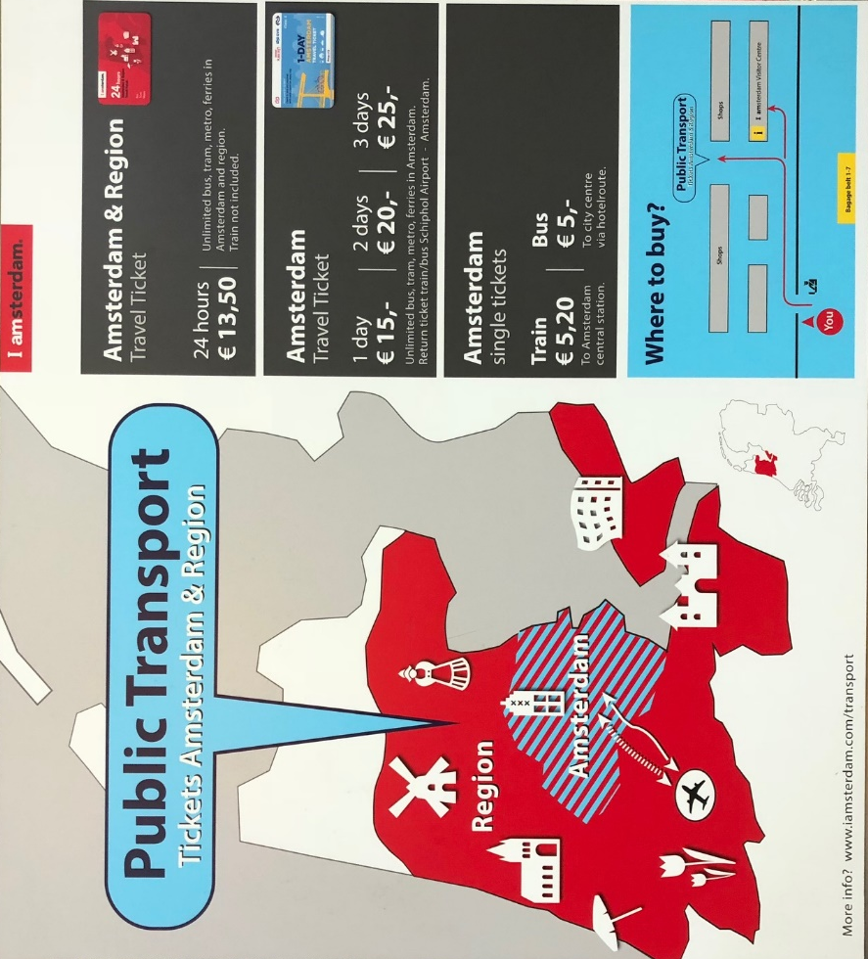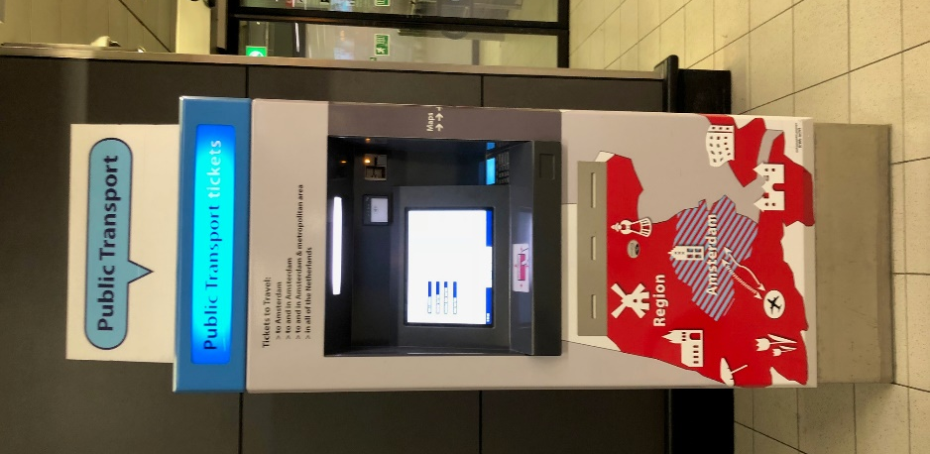
Overview of tickets. Vending machine at Schiphol Airport.

For planning your journey with the Dutch public transport system please check:
https://9292.nl/en/
The 9292-service is also available as an app on your mobile phone.

Route description to SCM office

SCM has its offices at the campus of the Free University Amsterdam. From Amsterdam Zuid station it is a 10 minute walk to the building were we are located (appr. 20 minute walk from the citizenM hotel). The route to SCM can be planned with Google Maps with the address De Boelelaan 1081A, Amsterdam. You can also check the exact location on the map below.

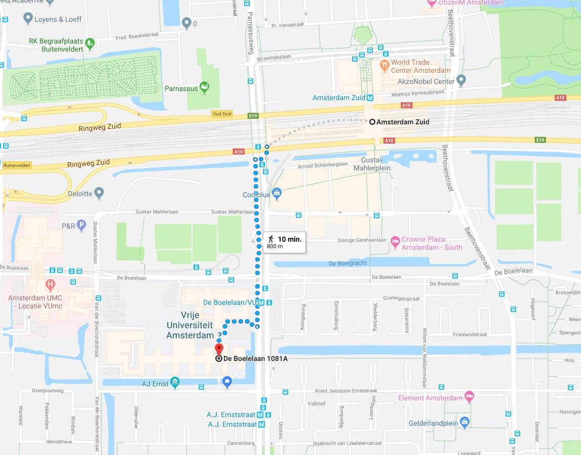

We are located in Faculty of Sciences building (Wis- en Natuurkunde gebouw). SCM is located in the R1-corridor. Take the stairs to the first floor, the corridors are alphabetically ordered.

If you get lost
Call us at +31 20 598 76 26 or +31 20 598 76 25.

