BASIC MANUAL FOR THE BCL METHOD.
This brief summary explains some of the main characteristics that allow executing and generating results using this computational method.
The data needed for calculate the different indicators of the BCL method come from the results obtained in two different calculations, using two different molecular geometries as shown in Figure 2. The method require information from the ground state of the molecule and from the first excited state.
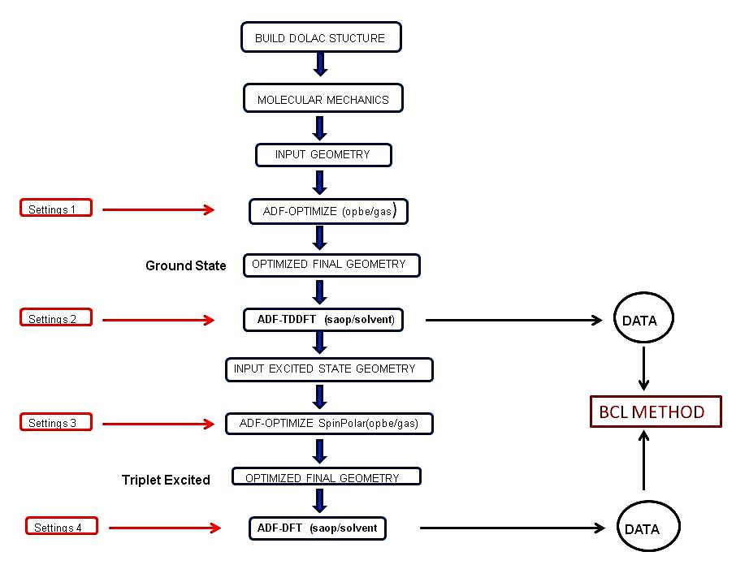
Figure 1 : General flow chart.
A typical run can be described as series single process executed in hierarchical order as showed in Figure 1. The first step is to build the target molecule in the Donor-Linker-Acceptor architecture identifying which groups are the Donor and Acceptor.
The calculation process begins with a pre-optimization of the geometry using Molecular Mechanics which quickly the initial coordinates to perform an optimization using DFT and the OPBE functions in gas phase. With the optimized geometry, TDDFT calculations are performed using the SAOP potential and solvent effects are included though the COSMO model. The values of energies and composition of molecular orbitals together with transition energies are used to feed equations of the BCL worksheet. Settings are the fine tuning parameters specific for each run like, precision, basis set ,fragments definitions, COSMO parameters etc..
A second type of calculation is carried out using spin polarization. Occupation numbers of the spin-orbital composition are modified in order to generate a triplet state electronic configuration. Molecular geometry optimization with these occupations number and ground state coordinated are employed has initial input. The optimized geometry is used for a DFT calculation with the SAOP exchange potential with acetonitrile as solvent medium. The energy levels, composition of molecular orbitals, together with the geometric data of this excited configuration feed the BCL worksheet.

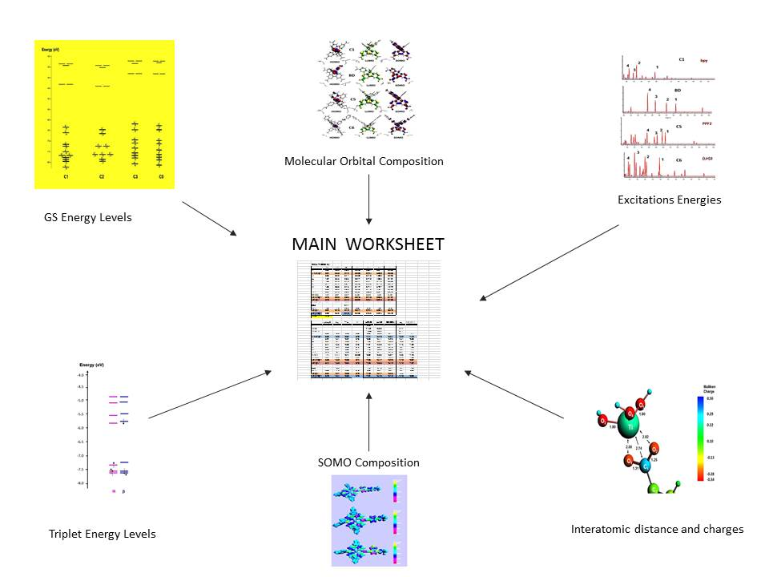
Figure 2: Data Entries

Figure 2 shows the different types of data collected after ADF runs which are stored in one single worksheet in which intermediate parameters are generated. These parameters are transferred to the main spreadsheet where the three indices are calculated. The values of the orbital energies together with their composition and the excitation energies provided by the TDDFT calculations are used to calculate the first and third factors. Calculations for the triplet like spin-orbitals energies and the composition of the Single Occupied Molecular Orbital (SOMO) are employed for the building the second index.

