HP Systems in Computational Chemistry
Case Study with Amsterdam Density Functional (ADF) Software

The second in a series of papers in which the computational requirements of ADF are characterized on HP platforms.


Executive Summary 2
Introduction 3
DFT Calculation for TPA in a ZSM-5 channel: A Typical Example 4
Comparative Results 7
Parallelism 7
Computing Architectures 8
I/O and File System Access 12
Interconnects 13
Memory 14
Conclusion: Reducing Overall Computational Time 15
Glossary of HP Terms 16
For more information 17

Executive Summary
Effective use of computational systems may simultaneously speed computational chemistry research and offer cost savings. Many factors may contribute to effective implementation. Using a realistic large molecule as a case study, HP and Scientific Computing & Modeling (SCM) characterized the configuration requirements of a Density Functional Theory (DFT) calculation with ADF®, SCM’s quantum chemistry program.
SCM supports HP-MPI for its optimized cluster implementation of ADF.
HP-MPI provides transparent application support of different clusters allowing developers and users to run the same MPI-based applications across multiple platforms and interconnects without the headaches of recompilation.
Excellent scaling, independent of architecture, is found for HP clusters (tested up to 128 cores), effectively reducing the overall computational time. For DFT calculations, clusters of Intel® Xeon® quad-core servers, such as HP Cluster Platform 3000BL, have a distinct performance advantage over clusters and also over current SMP platforms based on other processors.
Cluster performance, even with the fastest processors, is typically dependent on sufficient memory and I/O. ADF is a memory-intensive application and, for some job types, stores large amounts of data on disk. Using today’s typical configurations, this case study reveals memory was not a bottleneck to performance. I/O, on the other hand, was improved from typical Network File System (NFS) configurations with HP StorageWorks Scalable File Share (SFS)—delivering the best I/O performance, especially useful in large cluster configurations.
Performance on clusters may also be limited by interconnect speed. In this case study, parallel performance on clusters was significantly improved using high performance interconnects like InfiniBand.
The parallel efficiency of a particular ADF job depends on many factors. As a guide, this case study characterized the effect of a number of key cluster configuration variables on cluster performance, and compares that performance with single node SMP configurations. It also represents part of the collective analyses and understanding that HP and its partners develop in better supporting its computing customers in life and materials sciences.

Introduction
Typically, computational chemistry research projects require the running of numerous computational jobs, some of which may run for days, weeks, or months. Clusters may offer substantial time and budget savings if the software takes advantage of the distributed parallelism of cluster technology. Thus, understanding the factors affecting cluster performance becomes critical for researchers pushing the limits of their computational resources to study larger and more complex molecules. To that end, this paper describes a joint investigation of the parallel performance of SCM’s Amsterdam Density Functional (ADF) software on a number of configurations of HP Linux clusters and an SMP system. ADF is a widely used quantum chemistry program known for its efficient density functional methods.
The ADF software program
ADF focuses on electronic structure calculations based on Density Functional Theory (DFT). The DFT approach has earned a dominant position within the quantum chemistry community. This approach combines efficiency (systems with hundreds of atoms can be treated) with accuracy, and applies well to molecules that are difficult to handle with Hartree-Fock based methods.
The ADF package contains a periodic structure code BAND to study systems such as polymers, solids, slabs, and surfaces, and a COSMO-RS module to predict fluid thermodynamics. ADF is especially useful for the treatment of finite systems, such as transition metal compounds, molecules containing heavy elements, metal clusters, proteins, and molecules in a solvent environment.
In addition to standard calculations such as geometry optimization, transition state search, and analytical frequency calculations, ADF, which uses the Slater type basis sets, can calculate a wide variety of molecular properties, such as optical spectra, NMR, ESR, and hyperfine interactions. It can also deal with many types of environments, using QM/MM for protein environments, or COSMO and discrete models to account for solvent effects.
ADF is developed by a number of academic research groups in collaboration with SCM. Most developments in ADF have come from the Baerends group in Amsterdam, The Netherlands, and the Ziegler group in Calgary, Canada. For more information, see www.scm.com.
SCM has built into ADF software a number of features to reduce overall computational time, including the use of full molecular symmetry, distance cutoffs to achieve linear scaling with system size in performance critical parts of the code, the option to use frozen-core basis sets, and the use of an atom-pair based density fit. It has also been written to take advantage of compiler options and computer hardware features, and has been optimized to run on HP Linux clusters. In addition, users may further improve the performance of ADF on their clusters by reducing or eliminating bottlenecks on their systems.
Clusters are excellent for substantially reducing total job completion times for software that has been well parallelized. A typical ADF job on a single processor spends most of its time doing numerical integrations. These integrations involve thousands of integration points per atom and a straightforward subdivision of this numerical grid, over the available processors in a parallel run, is a simple and quite effective way to achieve effective parallel performance for this part of the code.
Part of the remainder of the ADF code deals with the density fit, which is done in a loop over atom pairs. These pairs may also be readily distributed over multiple processors to achieve efficient scaling.
Parallel performance may also be limited by load imbalances. If some atom pairs (such as heavy atoms with many fit functions) have a higher computational load than others, they will slow down the overall performance of that step. Slowdown may also occur if one part of the integration grid requires more computations, due to its central position in the molecule, than the rest of the integration grid. ADF is written to take these potential imbalances into account, but currently cannot fully eliminate them.

DFT Calculation for TPA in a ZSM-5 channel:
A Typical Example
ZSM-5, Zeolite Socony Mobil #5, has been studied extensively, because of its important commercial use. ZSM-5 is a synthetic catalyst used in the cracking to form gasoline. The material is a medium pore zeolite with polar channels defined by ten member rings.

Tetrapropylammonium (TPA) is usually employed in the synthesis of ZSM-5. In the process it is often included in the zeolite crystalline structure.

In this study, we examine a fragment of a ZSM-5 zeolite channel with a TPA. The formula of the fragment studied here is Si₃₅O₈₇C₁₂NH₆₁.

Figure 1. The study molecule: Si₃₅O₈₇C₁₂NH₆₁
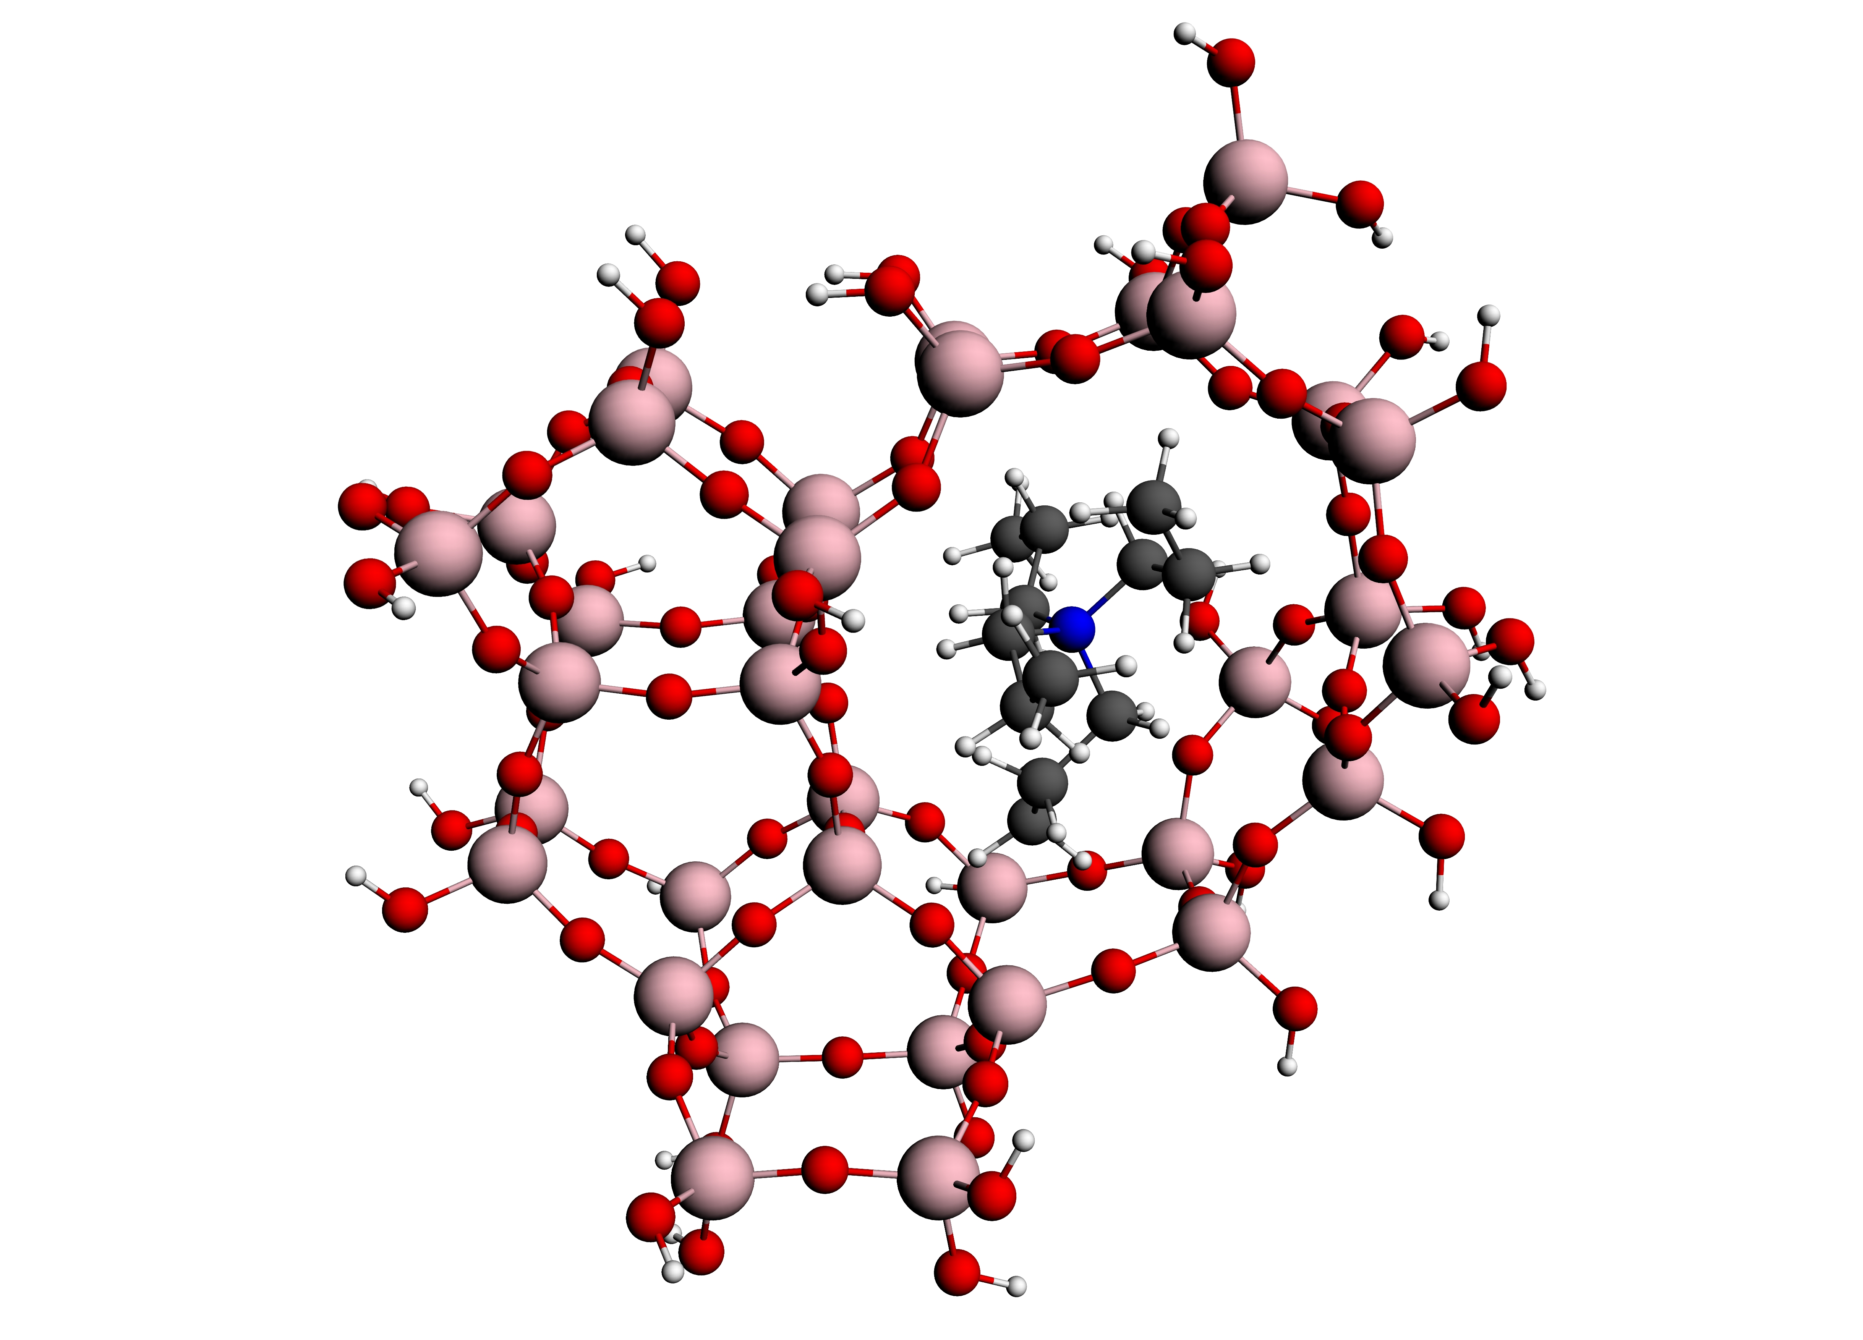

Calculation of TPA in a ZSM-5 channel does not require as much computing power as the Metallophthalocyanine model used in the previous paper, but is probably more relevant for the average ADF user. Although the size of the molecules is similar, this benchmark is very different in many ways: there is no symmetry so the matrix diagonalization (dsyevx from Lapack) may become a bottleneck at high CPU count. Therefore, ScaLapack becomes more important for this benchmark. In the latest version, ADF utilizes ScaLapack from Intel MKL. Another, and more important, difference between the studies is that the code that calculates forces on atoms is benchmarked here. If you look at the average ADF usage, then this portion of ADF is executed much more frequently here than in the previous study.
To improve the ease of running ADF on clusters, SCM adopted HP-MPI. Unlike MPICH and other common flavors of MPI, HP-MPI enables ADF to run on clusters with different interconnects without the need to recompile. The use of HP-MPI by ADF eliminates the headaches associated with recompilation due to link problems and issues resulting from differing compiler versions. With HP-MPI, communications can be faster. With ADF, speedup may be negligible in terms of its overall performance as communications are not a significant part of ADF runs.

Table 1. The calculation was performed on the following configurations.
For a complete description of the product terminology, please see the Glossary.
Cluster type | CP3000BL | CP4000 | CP6000BL
Node type | BL460c | DL165 | BL860c | DL785 | rx8640
Architecture | Xeon 5450  (quad core) (3.0GHz) | AMD 2360  (quad core)  (2.5GHz) | Itanium 2  (dual core)  (1.6GHz) | AMD 8356 (quad core)  (2.3GHz) | Itanium 2  (dual core)  (1.6GHz)
Processors/Core | 2-processor  8-core | 2-processor  8-core | 2-processor  4-core | 8-processor 32-core | 16-processor 32-core
Cache Configuration | 4 MB shared between 2 cores | .5 MB private/core  2 MB shared between 4 cores | 9 MB/core | .5 MB private/core  2 MB shared between 4 cores | 9 MB/core
# Nodes x  Cores per node | 16 x 8 | 16 x 8 | 8 x 4 | 1 x 32 | 1 x 32
Memory per node | 16 GB | 16 GB | 8 GB | 64 GB | 128 GB
Interconnect | InfiniBand ConnectX / Gigabit Ethernet | InfiniBand ConnectX / Gigabit Ethernet | InfiniBand SDR / Gigabit Ethernet | n/a | n/a
O/S | XC V4 | XC V4 | RHEL 5.2 | RHEL 5.2 | RHEL 5.2

All the cluster configurations are part of the HP Unified Cluster Portfolio (UCP) that combines the flexibility of a custom solution with a wide choice of platforms, systems, interconnects, and software options with a preconfigured, pre-tested, factory-built product. HP’s UCP and its Cluster Platforms (CP) are specifically targeted at high performance computing users to allow them to focus on running their jobs on clusters of 5 to 1024 nodes.
XC System Software, supported by HP, is based on a standard Linux (Red Hat Enterprise Linux) distribution combined with both commercial and open source packages. This open source base combined with technology from HP and its partners provides a complete solution for development, execution, and management of simultaneous parallel and serial applications. Included in this is support for both Network File System 3 (NFS) and HP StorageWorks Scalable File Share (SFS), a powerful cluster file system that gives users of Linux clusters scalable storage (scaling to over 35 GB/sec aggregate bandwidth with a capacity that scales from 1 TB to 512 TB) that is easy to use and easy to administer.
For more information on HP Unified Cluster Portfolio and the individual cluster solutions, go to h20311.www2.hp.com/HPC/cache/275420-0-0-0-121.html

Comparative Results

Parallelism
The efficiency of scaling is measured by running the test calculation on various HP Linux clusters with up to 128 processors. The results reveal excellent scaling (graphs 1 and 2) for all three cluster architectures tested. No significant differences in scaling appeared among the three architectures tested (graph 2). For up to 32 processors, speed-up in performance is excellent -- in the range of 1.67 to 2.0 when doubling the processor count. From 32 processors to 64 processors, scaling falls off to between 1.5 and 1.6. Going from 64 to 128 processors, scaling falls off further to 1.35.

Graph 1. Cluster Performance of HP CP3000BL cluster of HP BL460c Blade servers from one to 128 cores.
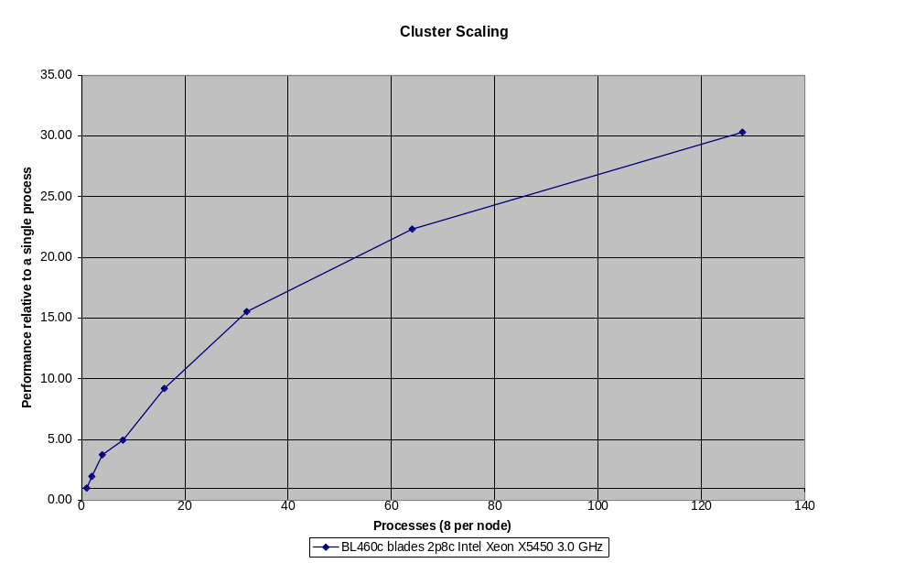

Configuration details for Graph 1
HP CP3000BL, comprised of HP BL460c Blade 3.0GHz (2p8c; Intel Xeon X5450 3.0 GHz) servers with InfiniBand ConnectX interconnect running XC V4.0, with 16 GB memory/server

Computing Architectures

Graph 2 also shows the relative performance of clusters based on three multi-core computing architectures: Intel’s Itanium2 and Xeon processors and AMD’s Opteron 2200 Series processor. The Intel® Xeon® quad-core servers, such as the HP BL460c, currently have a useful performance advantage (>40%) over servers based on other processors when running ADF on 1,2 or 4 cores in a single server, but the AMD Opteron based quad core servers scale better and match the Intel based servers in an 8 node cluster using 64 cores.

Graph 2: Cluster Performance of various HP Multi-core Servers
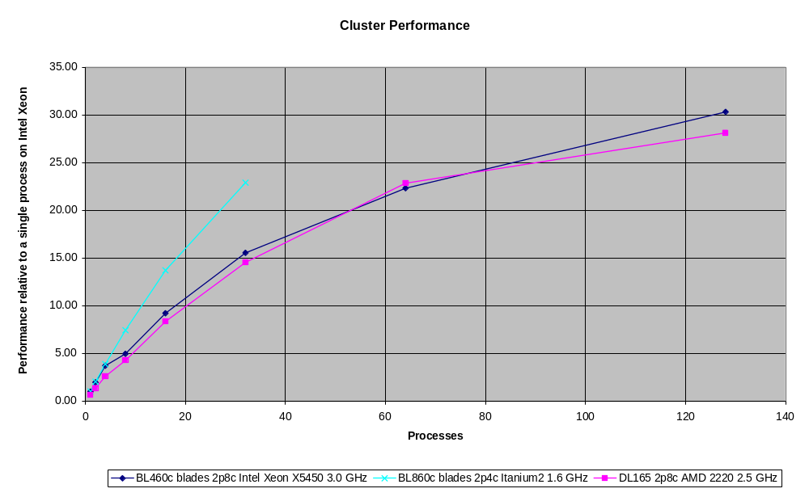

Configuration Details for Graph 2
HP CP3000BL, comprised of HP BL460c Blade (2p8c Intel Xeon X5450 3.0 GHz) servers with InfiniBand ConnectX interconnect running XC V4.0, with 16 GB memory/server
HP CP4000 with HP ProLiant DL165 (AMD Opteron based 2p8c 2.5 GHz) servers, running XC v4.0; with InfiniBand ConnectX interconnect
HP CP6000BL with HP Integrity bl860c Blades (2p4c; Itanium2 1.6 GHz) servers running Red Hat Enterprise Linux 5.2, with 8GB memory per server; InfiniBand ConnectX interconnect.

Graph 3 shows the relative performance of multi-core Symmetrical Multi-Processing (SMP) servers based on Intel’s Itanium 2 and AMD’s Opteron 2200 Series processors. Performance is closely matched up to 16 cores, but the DL785 (AMD Opteron) server doesn’t scale well beyond that due to memory bandwidth limitations.

Graph 3: Relative SMP performance of various HP Multi-core Servers
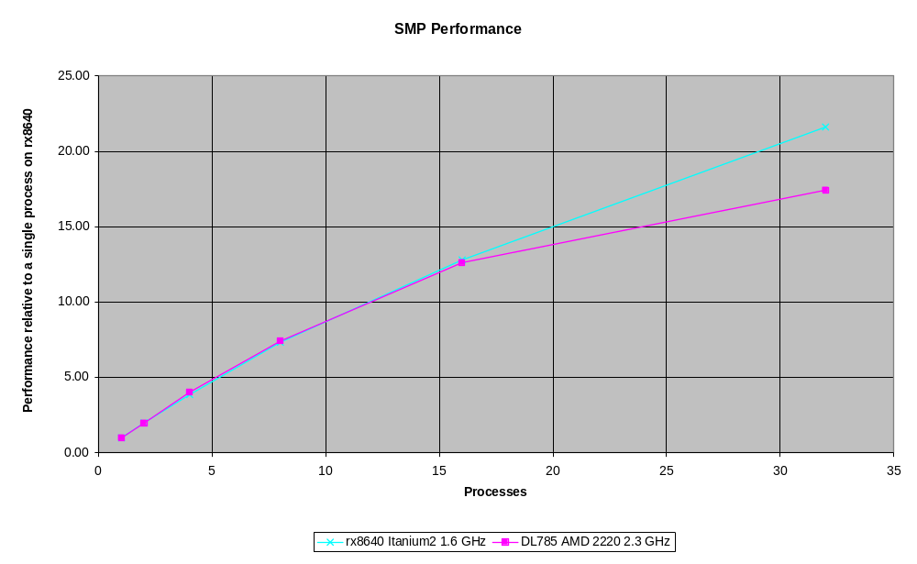

Configuration Details for Graph 3
HP Integrity rx8640 (16p32c Itanium2 1.6 GHz) 128GB server running Red Hat Enterprise Linux 5.2
HP ProLiant DL785 (AMD Opteron based 8p4c 2.3 GHz) server running Red Hat Enterprise Linux 5.2

Graph 4 compares the relative performance of both clusters and symmetrical multi-processing (SMP) systems based on similar Intel’s 1.6GHz Itanium 2 processors. Performance is closely matched, showing good parallel scaling for ADF on both systems.

Graph 4: Relative performance of HP Itanium 2 Clusters and SMP systems
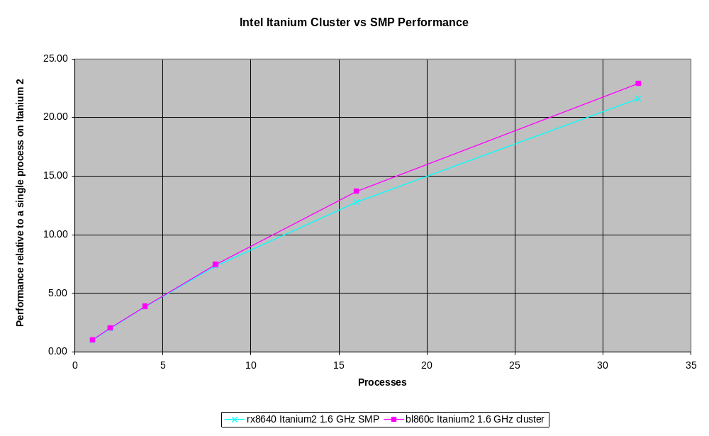

Configuration Details for Graph 4
HP Integrity rx8640 (16p32c; Itanium2 1.6 GHz) 128GB server running Red Hat Enterprise Linux 5.2
HP CP6000BL with HP Integrity bl860c Blades (2p4c; Itanium2 1.6 GHz) servers running Red Hat Enterprise Linux 5.2, with 8GB memory per server; InfiniBand ConnectX interconnect.

Graph 5 compares the relative performance of both clusters and symmetrical multi-processing (SMP) systems based on AMD Opteron quad-core processors. Performance up to 8 cores (single node) is closely matched, but the SMP does not scale as well beyond 8 cores due to memory bandwidth limitations.

Graph 5: Relative performance of AMD Opteron Clusters and SMP systems
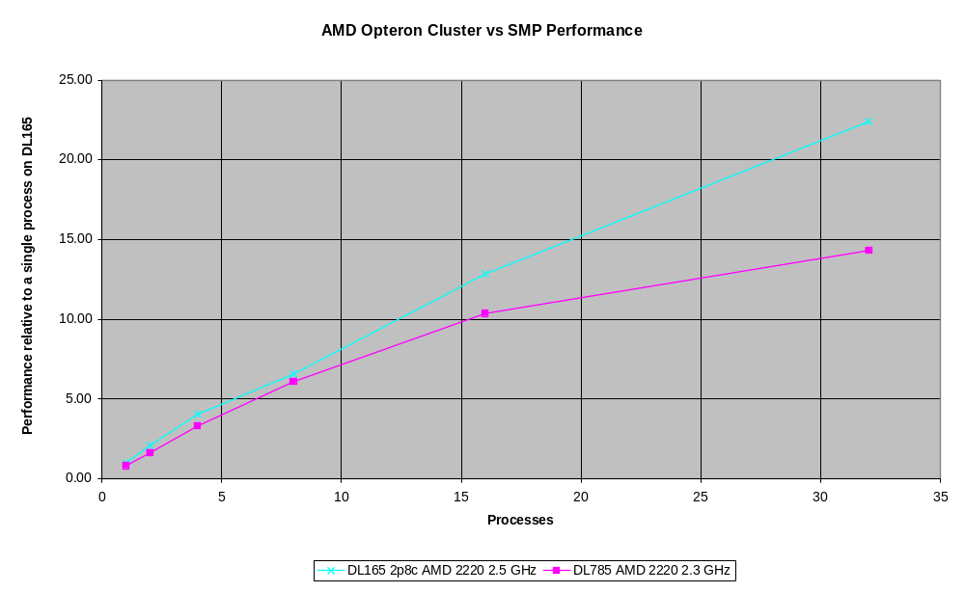

Configuration Details for Graph 5
HP CP4000 with HP ProLiant DL165 (AMD Opteron based 2p8c 2.5 GHz) servers, running XC v4.0; with InfiniBand ConnectX interconnect
HP ProLiant DL785 (AMD Opteron based 8p4c 2.3 GHz) server running Red Hat Enterprise Linux 5.2

I/O and File System Access
I/O can often be a performance bottleneck when an application stores much of its data on disk. Network File System (NFS) , the current de facto standard for accessing files, works well for small clusters of up to 16 cores, but I/O access time levels off as the cluster increases in size. Better performance is achieved when data is stored locally on a system’s internal disks. HP StorageWorks SFS G3 performs as well as NFS for smaller clusters, and it performs the best for larger clusters. This may be attributable to its ability to distribute files in parallel across clusters and storage components, resulting in higher aggregate bandwidth.

Graph 6: I/O Comparisons on a CP3000BL Cluster
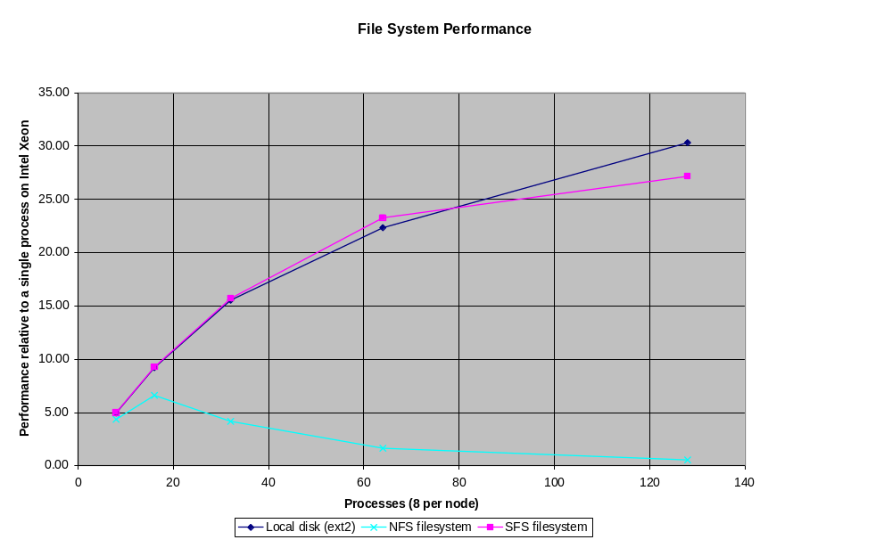

Configuration Details for Graph 6
HP CP3000BL, comprised of HP BL460c Blade 3.0GHz servers with InfiniBand ConnectX interconnect running XC V4.0, with 16 GB memory/server
HP StorageWorks SFS G3
NFS V3
/usr/local/tmp: local ext2 filesystem

Interconnects
Parallel performance on clusters was significantly improved using high performance interconnects. With larger clusters, job completion time is increasingly improved by InfiniBand’s higher speed (up to 750 MB/sec vs. Gigabit Ethernet’s 60-80 MB/sec) and lower MPI latency (<6 µSec vs. Gigabit Ethernet’s >40 µSec).

Graph 7: Interconnect Performance
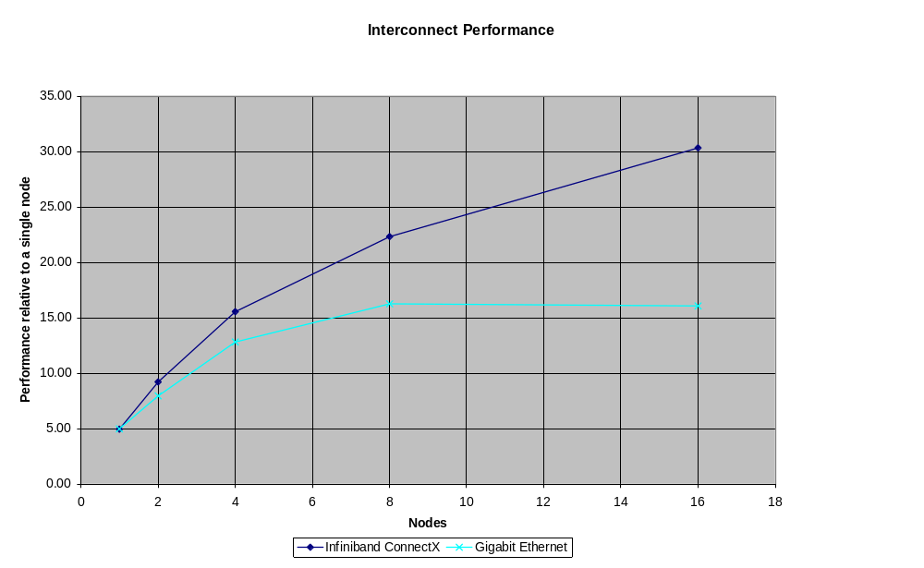

Configuration Details for Graph 7
HP CP3000BL, comprised of HP BL460c Blade 3.0GHz servers with InfiniBand ConnectX interconnect running XC V4.0, with 16 GB memory/server
Gigabit Ethernet and InfiniBand ConnectX Interconnect Tested
ADF has adopted HP-MPI for its cluster communications

The benefit of high speed interconnects increases over time as the compute power of each node increases, and overall elapsed time decreases, and is more significant now than at the time of the previous ADF Case Study** two years ago. The compute power of each node is significantly enhanced by multi-core processors. The effect of high speed interconnects becomes more significant with higher node counts, almost doubling the performance of 16 node Intel Xeon cluster (128 cores).

Memory
Multi-core performance is dependent on the availability of sufficient memory. In this particular case study, each MPI process uses a maximum of 700 MB of memory. Graph 8 shows that a system configured with a minimum of 1GB/core gives good performance, while 2 GB/core provides near optimal performance. Conversely, running 8 parallel processes with only 4GB of memory configured leads to excessive swapping and resultant degradation of performance.

Graph 8: Memory Configuration
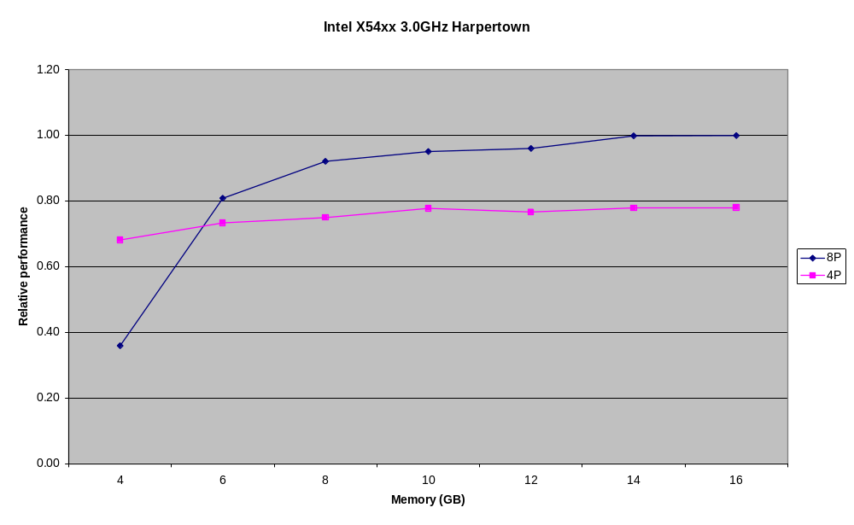

Configuration Details for Graph 8
BL460c Blade 3.0GHz servers with InfiniBand ConnectX interconnect running XC V4.0, with up to 16 GB memory/server

Conclusion: Reducing Overall Computational Time
Clusters effectively reduce the overall computational time, demonstrating excellent scaling up to 128 processors. For DFT calculations, clusters of Intel Xeon quad-core servers, such as HP CP3000BL, have a useful performance advantage over clusters based on Intel Itanium or AMD Opteron processors. Clusters based on AMD Opteron and Itanium 2 processors also demonstrate better scaling than SMP systems based on the same processor.
ADF is a memory-intensive application and, for some job types, stores large amounts of data on disk. Performance can be negatively affected even with the choice of the fastest computing architecture if memory and I/O are insufficient. In this particular case study, each MPI process used a maximum of 700 MB of memory. A system configured with a minimum of 1GB/core would give good performance, but 2 GB/core is required for near optimal performance. I/O, on the other hand, can be improved from typical NFS installations. Either adequate local disk or HP SFS G3 is important for ADF, both of which deliver good I/O performance. SFS, being a shared file system, offers better manageability, with excel capacity available to other parts of the cluster.
HP Cluster Platform 3000BL Performance
For DFT calculations, clusters of Intel Xeon quad-core servers, such as HP CP3000BL, have a distinct performance advantage over other architectures.
Finally, performance on clusters may be limited by interconnect speed which becomes increasingly important for larger clusters of 64 or 128 cores or more. Effective parallel speedups of large clusters require high performance interconnects. Because ADF supports HP-MPI, most interconnects are supported out of the box. The choice of which interconnect to use depends more on whether inter-server communications will be a bottleneck in the mix of jobs to be run.
HP InfiniBand ConnectX Performance
High speed interconnects, such as InfiniBand ConnectX, deliver optimum cluster performance.
The parallel efficiency of a particular ADF job depends on many factors. If one uses a much more accurate numerical integration grid than the default, then the part of the code that is effectively parallelized moves towards 100%. Excellent scaling will be achieved for these simulations. Excellent scaling is also archived in parts of the code which have been parallelized, but have not yet been optimized to the fullest, which increases the parallel percentage of the code and simultaneously removes several load balancing problems for serial parts of the code. Lengthy calculations that do not require frequent diagonalizations, such as analytic frequency calculations, are also among the best scaling ADF jobs. Finally, the symmetry of a molecule reduces both the size of the grid and the dimensions of the matrices that need to be diagonalized, which also affects parallel scaling.
HP continues to partner with commercial and academic software providers in Life & Materials Sciences. Collaborative projects to characterize key applications and optimize their performance on our computing solutions are a significant part of that partnership. For more information, check http://www.hp.com/go/lifesciences.

Glossary of HP Terms
CP | Cluster Platform—HP’s cluster configuration families based on specific processor architectures:  - CP6000BL: HP Integrity server cluster family based on Intel Itanium 2 (2 processor/4 core [2p4c]) servers  - CP3000BL: HP ProLiant DL server cluster family based on Intel Xeon (2p8c) servers  - CP4000: HP ProLiant DL server cluster family based on AMD Opteron (2p8c) servers  HP provides consistent terminology to describe single core and dual core technology. The same terminology is used by both Intel and AMD.
Number of processors | The number of physical chips (A processor may contain more than one core.)
Number of cores | The processing unit within a processor (There may be more than one core within a single processor/physical chip.)
HP-MPI | HP’s implementation of the de-facto standard Message Passing Interface (MPI). HP-MPI supports multi-protocol execution of MPI applications on clusters of shared memory servers and provides transparent support of a broad range of interconnects and architectures. It supports HP-UX, Linux, and Tru64UNIX operating systems and interconnects such as TCP/IP, InfiniBand from Voltaire, Cisco, Silverstorm and Mellanox, Myrinet GM-2 and Myrinet MX, HyperFabric2 and Level 5 Etherfabric from Level 5 Networks. It also supports shared memory for intrahost transfers as well as Quadrics Ltd. QsNet on Linux Intel Itanium2 based systems. HP-MPI is also thread-safe.
HP SFS | HP StorageWorks Scalable File Share. A high performance, high availability global I/O and shared file server that gives users of Linux clusters scalable storage (scaling to over 35 GB/sec aggregate bandwidth with a capacity that scales from 1 TB to 1024 TB) that is easy to use and easy to administer.
UCP | HP’s Unified Cluster Portfolio delivers flexibly configured clusters with a wide choice of platforms, systems, interconnects, and software options and the simplicity, reliability and value of a preconfigured, pre-tested, factory-built product.
XC | System Software supported by HP that is based on a standard LINUX (Red Hat Enterprise LINUX) distribution combined with several open source packages.

References

**Case study “HP Clusters in Computational Chemistry” published in 2006

For more information

www.hp.com/go/lifesciences
© 2009 Hewlett-Packard Development Company, L.P. The information contained herein is subject to change without notice. The only warranties for HP products and services are set forth in the express warranty statements accompanying such products and services. Nothing herein should be construed as constituting an additional warranty. HP shall not be liable for technical or editorial errors or omissions contained herein.
Itanium is a trademark or registered trademark of Intel Corporation or its subsidiaries in the United States and other countries.
ADF is a trademark or registered trademark of Scientific Computing & Modelling NV in the United States and other countries.

